Architecture Pointers:

1. **Login Page**: The login page of netViz is a standard login page with the functionalities of *sign in* and *remember me*. Any credential created is stored in native database (SQLite) in encryted format for added security. If user enables *remember me* function, every time the url is hit, last login credentials will be used to login and user will be redirected to Home page.

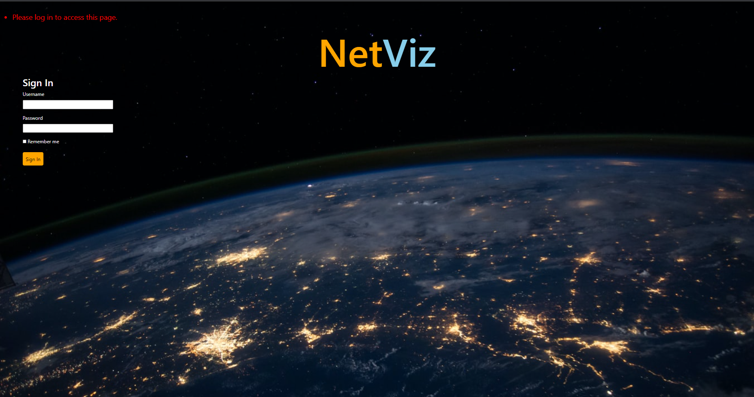

1. **Home Page**: Once user logs into the website, the home page of netViz will be visible. The page contains a greeting message in the form of “Hi, <username>” and search bar which is used to perform all the searches. Other than the search bar the NetViz and Home buttons are also present on top left-hand corner. As of now, clicking on both Home and NetViz will redirect the user back to the current window no matter whichever window the user is viewing currently (except login). With future iterations, the plan is to add corresponding clickable options along with Home and NetViz for Admin and User defined searches. When those solutions come into picture, NetViz will be used to redirect to this search app.

Search functionality is to allow users to perform search on any of the 5 below details:

* Customer ID
* Customer Name
* Address
* Phone Number
* A/C Number

If there is any data present in the data source for these 5 fields, they can be searched using this feature. This search bar offers a few functionalities seen in industry standard search engines like Search Suggestions and Partial String Searches.

With Search suggestion, a minimum of 2 characters should be entered for the suggestions to come up (in order to return sensible searches). At any point of time, a maximum of 15 search suggestions will be provided in the suggestion drop down. As the user goes on fine tuning, the matches will reduce till the exact match is provided. During this process, user is capable of selecting any of the provided suggestions by using arrow keys + enter or click on mouse and the search string will be selected. User can then perform a search using this by simply clicking on the search icon next to the search bar.

Partial String Search offers an option to perform a search using a partial and incomplete string. This ensures that the user is capable of quickly performing a search or if the user is not aware of the complete details. If a search is performed using this functionality, the application will check for the matches in all of the 5 fields i.e. Customer ID, Customer Name, Address, Phone Number and A/C Number. And for every match there is, all the records will be returned back. The user can view the results to pin-point the search they were willing to go for.

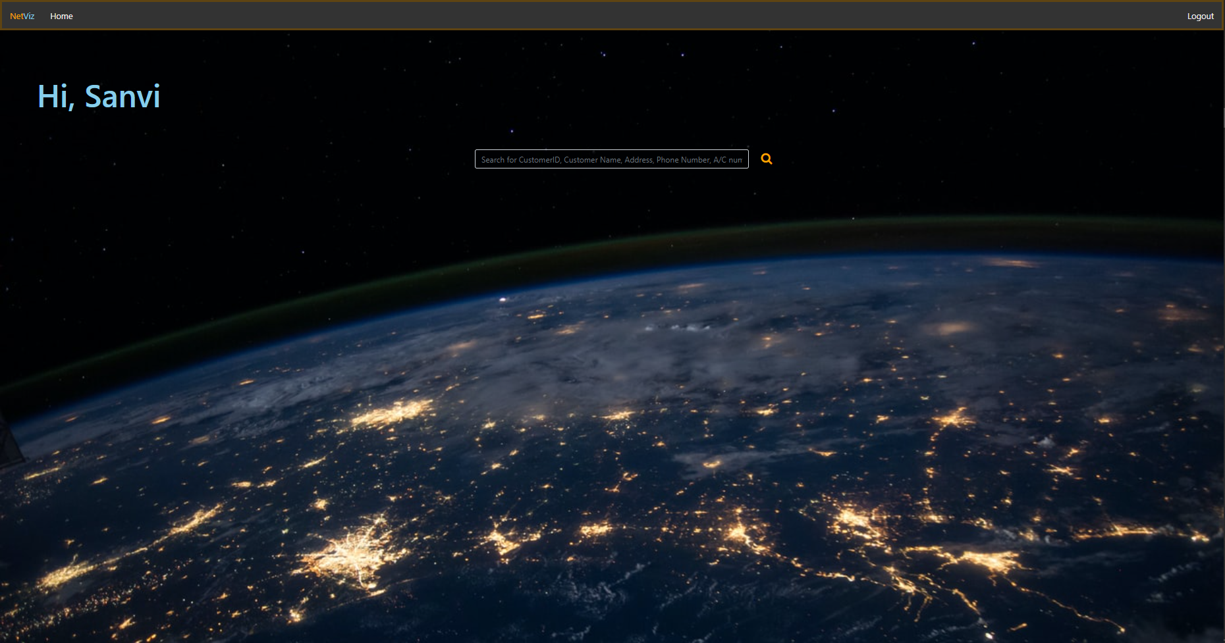

1. **Search Result**: Based upon the type of search performed, the results retrieved from the data source will be provided in a tabular format. The table contains customer ID, customer name, address, phone number and account number. If an exact match is searched for (like customer ID) then the search result will be a single row otherwise, there may be as many records as possible for partial string searches. User has the ability to scroll down to view the data displayed.

Each data set returned will have data as provided by the source. Hence, in the event of a certain record not being available in the data source, the value populated will be “None”.

Finally, below the search results table, at the bottom right corner, there is a small string depicting the string being searched for. This will be useful especially for the partial string searches. User will always be capable of tracking on what the searches have happened.

This page also has the search bar. The page also contains NetViz and Home as per the previous page. The Search bar if clicked and typed in when there is a search result displayed, the search results will be cleared off for the new data to be loaded.

As soon as the user hovers the cursor over any of the rows, they will be highlighted with black background and on clicking will redirect to graph generation window.

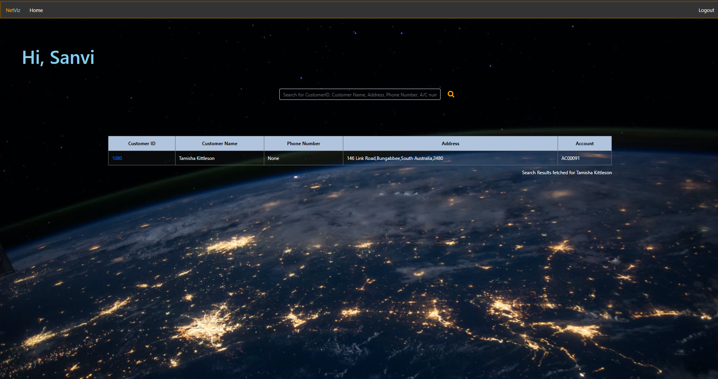

1. **Network generation**: This is the main functionality of the application. As soon a row is selected in the previous page, a network graph will be generated. This is a graphical representation of all the data points currently available for the selected customer. The concept is customer in the centre and all related assets like accounts, transactions, addresses, contact, identification, relationships and any other information available in the data source will be converted into a network having connection with customer in the middle. For this demo we are having a customer connected to an Account with transactions, addresses, contacts and identification documents as connected nodes.

The graph itself has a couple of functionalities such as drag and drop. If any node (other than customer) is selected and dragged to anywhere within the provided sub-window (highlighted by shadow), the node will move along with the connected edge. This allows the user to play around with the graph to reposition everything and understand the connections.

Also, there is another functionality for each parent node. All the nodes directly connected to Customer is a Parent node (account, contact, address & identification info). These are all collapsible. Clicking on them will collapse the child-nodes i.e. sub nodes connected to parent nodes. Re-clicking on the parent node will expand the child nodes. This functionality will allow users to focus only on the required nodes and their data while ignoring the others in case of a large and complex graph.

Each node has a floating card. The card becomes visible when mouse is hovered on it. The node will then represent the data provided from the data source for that respective record. For example, in the network sample provided, each customer detail card has the below descriptions:

* Customer name
* Gender (only for individual)
* Customer type
* Date of birth
* Country (of origin)

Similarly, if the node selected is Address, the child address selected is Office, Residence or Postal as provided by the database.

Other than the graph, there is string mentioning the name of the customer for which graph is generated on top-left hand corner. On the top right-hand corner, there is a floating window that allows configuration of the graph elements. These include:

* Node Distance
* Attraction
* Stiffness
* Hold Elements

This is generated using a Json file from the data source. This json file generated can be connected to any data source for integration with any other data source. Hence, this application is readily deployable.

